Lord of the Flies
Student’s Name
Institutional Affiliation & Department
Course Title
Instructor’s Name
Date

Lord of the Flies
- Summary of Chapter Seven – Shadow and Tall Trees
The boys continue hunting the beast in the forest when the chapter starts. They seize eating and keep walking towards the mountain. Ralph is not in good moods, as the boys are not behaving well in their mission. The boys become hard to manage, and he is uneasy when he imagines their hope to escape from the island as the big waters of the ocean surrounding them, making it hard and almost impossible to reach their destiny. Nevertheless, Simon is optimistic, clears Ralph's fears, and restores his hope as he assures him that they must make it to their homes. His spirit then arises, and he is determined that they have to focus and strive for their safety, home.
On their hunting mission, the boys find pig droppings, and one of them proposes that they start hunting the pigs alongside their original mission of hunting the beast. They eventually come to a mutual agreement and incorporate to hunt the pig. They track a huge boar, which leads them to a wild chase. Ralph has never been in a wild hunt before and finds it hard for him to escape. Thus, he is easily caught in the chase but tries to fight for his life. He aims his spear towards the boar, where he spikes it in the snout. This is a great achievement to Ralph since he has never made such an action in his life. However, Jack tries to hold his hand up, which is wounded by the boar in the chase process. The boar had grazed him with its tusks, leaving him wounded and heavily bleeding.
In the process, the boar runs away, leaving the boys afraid and shaken. They, therefore, decide to replay the scene where one of them, named Robert, acts as the boar, and they start chasing among themselves. They chase the "Boar," who is Robert, until they forget that it is a play, and they seriously start hunting him, trying to kill him. They forget that it was a play, and they use their spears, chasing, dancing, and jabbing Robert. They almost killed him in the process, before they recollect themselves and come back to their senses that it was just a play and Robert runs away. Ralph tries to remind them that it was just a game, and Simon volunteers to go back to the beach and report to Piggy and the littluns that the boys would be late to return, and probably they would be back very late in the night.
Darkness finds the boys still in the wild, and Ralph suggests that they wait for the morning and head to the mountain to hunt the beast since it would not be easy for them to hunt it at night. Jack dares Ralph to join them in the hunt, where he takes some time to agree and accept to join them and takes back his position in the group. The three, Jack, Roger, and Ralph, start climbing the mountain. Jack climbs to the peak as the rest, Roger and Ralph, wait behind him. Jack returns running, claiming that he had seen the monster, which makes the other anxious and curious. They also climb up and notice a huge ape-like giant, which horrifies the boys and start running down the mountain to join the rest of the group, where they notify them of the danger.
- Chapter 8 Questions with Answers
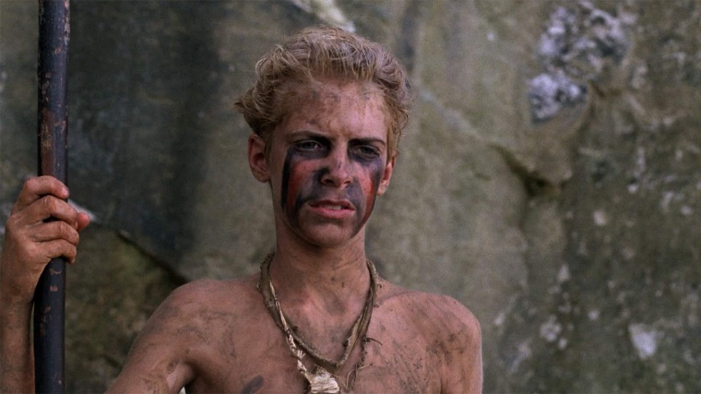
Question 1.
How did Jack react when Ralph termed his hunters as "Boys armed with sticks"?
Answer:
Maybe, Jack feels offended and tries to tell his friend that Ralph called them cowards, and thus he thinks that Ralph is not a good leader to the group.
Question 2:
Are there some people who did not vote and did not want Ralph to be their leader?
Answer:
Maybe the members felt that Ralph was their best choice and suited for their leader, chief.
Question 3:
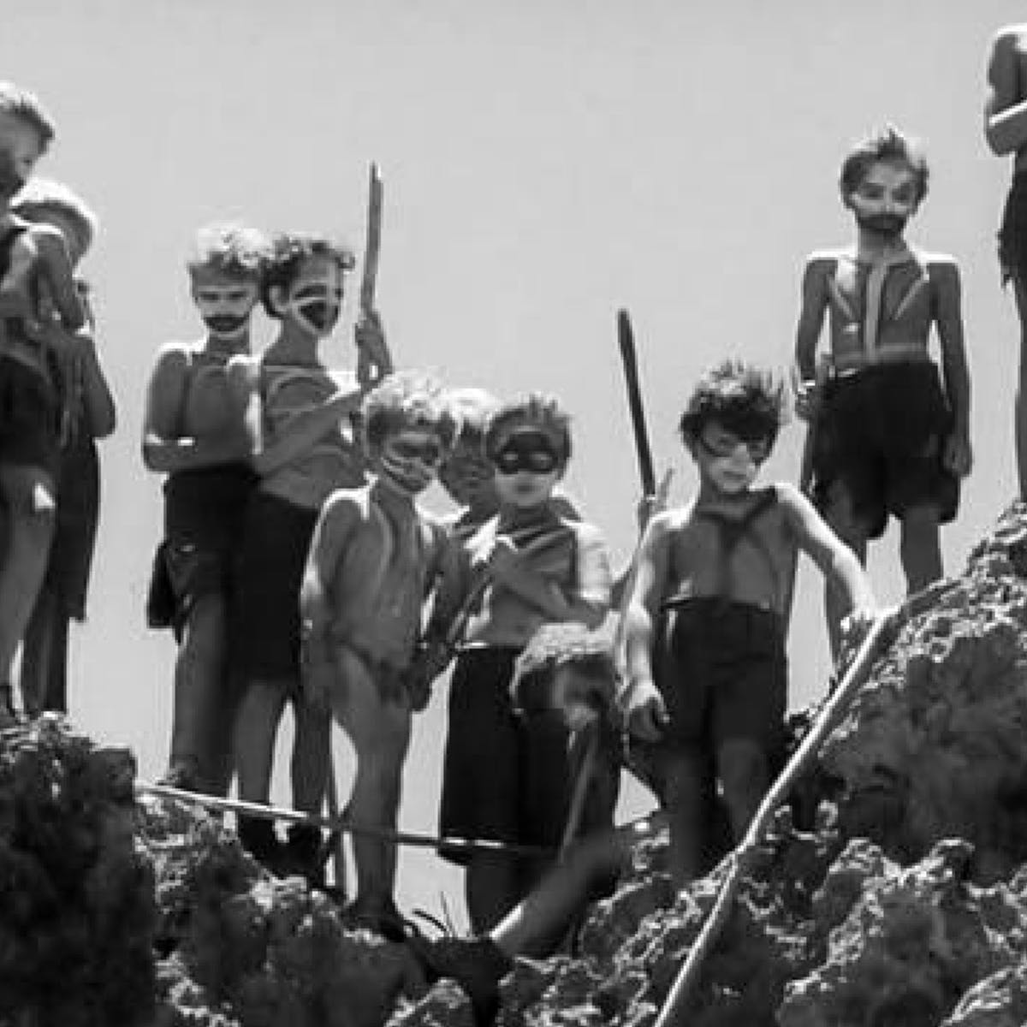
Why and how did the hunters acquire a new title?
Answer:
Maybe the hunters were named savages because they were breaking away, killing, torturing, and painting their bodies and faces as well as stripping down.
Question 4:
What do you think was Jack’s reaction when he noticed that no one rejected Ralph as their chief?
Answer:
Maybe, Jack was angered and did not want Ralph to be their chief, so he walked away.
Question 5:
Why do you think that Piggy and the twins brought Ralph a feast of fruit?
Answer:
Maybe they wanted to please him as their new chief.
- Character in the Novel: Ralph (Question 4)
Ralph is a character in the novel which was elected as the crew's chief. The author displays the young boy, Ralph, twelve years, as a charismatic and courageous leader. He primarily leads to order, civilization to his group, and he is displayed as a very productive leader in the novel. He is a very influential leader, as displayed, who mobilizes his group for change. He is a very concerned young leader for his group as he leads them where he wins power to influence and lead the other boys.
Despite him being opposed and objected to by other people like Piggy and Jack, Ralph remains determined to develop morality and civilization in the group. He shows this when he tries his best to defend himself and the tribe as he defeats the hunters from Jack's side. He also confirms to be a concerned leader when he tries to construct huts for his group for shelter on the island.
Ralph is among the oldest people on the island, which could be one reason he was elected the leader of his group. Despite the challenges, Ralph remains disciplined and ever respected Piggy. However, he is not pleased with him at first. His role as a leader faces several challenges, including Jacks's opposition and torments to his group, which leads to his boys turning to grow some savage behavior.
In the novel, the author presents Ralph as a symbol of democracy and as a government to his group, and he is displayed as an agent of change who stands firm to his stand and focused on bringing the change to his people.

